**DESIGN DOCUMENT**

**1. Architecture Overview**

NattyWorld is built upon the MERN (MongoDB, Express.js, React.js, Node.js) stack:

* **Frontend:** Developed with React.js, NattyWorld offers interfaces for users to engage with personalized diet plans, workout routines, BMI calculation, gym location services, and user authentication.
* **Backend:** Powered by Express.js and Node.js, the backend provides RESTful APIs for user authentication, diet planning, workout planning, BMI calculation, gym location services, and AI integration for generating personalized plans.
* **Database:** MongoDB serves as the database to store user data, diet plans, workout plans, gyms, and related information.

**2. Database Design**

NattyWorld's MongoDB database consists of the following collections:

* **Users:** Stores user information, including name, email, password hash, and preferences.
* **Diet Plans:** Contains personalized diet plans generated for users, comprising meal schedules, nutritional information, and recipes.
* **Workout Plans:** Stores personalized workout plans generated for users, detailing exercises, sets, reps, and rest intervals.
* **Gyms:** Contains information about nearby gyms, such as name, address, contact information, and facilities.

**3. Schema Modals**

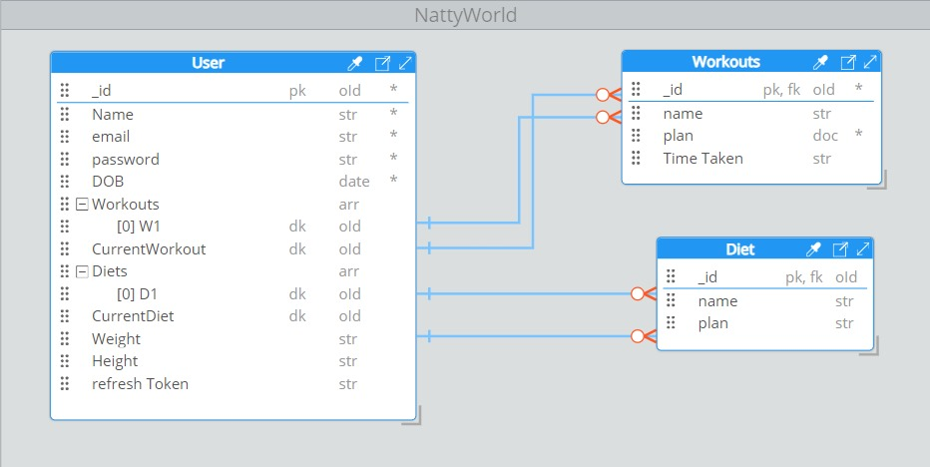

**4. API Design**

NattyWorld backend offers RESTful APIs for various functionalities:

* **Authentication APIs:**
  + /api/auth/register: Register a new user.
  + /api/auth/login: Authenticate user credentials and generate a JWT token.
  + /api/auth/user: Retrieve current user details.
* **Diet Planner APIs:**
  + /api/diet/plans: Generate personalized diet plans for users.
  + /api/diet/plans/:id: Retrieve, update, or delete diet plans by ID.
* **Workout Planner APIs:**
  + /api/workout/plans: Generate personalized workout plans for users.
  + /api/workout/plans/:id: Retrieve, update, or delete workout plans by ID.
* **BMI Calculator APIs:**
  + /api/bmi/calculate: Calculate BMI based on user input.
* **Gym Locator APIs:**
  + /api/gyms: Fetch nearby gyms based on user's location.
  + /api/gyms/:id: Retrieve details of a specific gym by ID.

**5. Frontend Design**

NattyWorld's frontend, developed using React.js and styled with CSS, encompasses various components:

* **Homepage:** Introduces the website and its features.
* **User Authentication:** Facilitates sign up, login, and logout functionalities.
* **Dashboard:** Personalized dashboard exhibiting diet plans, workout plans, progress, etc.
* **Diet Planner:** Allows users to input dietary preferences, view personalized diet plans, and access recipes.
* **Workout Planner:** Enables users to specify fitness goals, view personalized workout plans, and access exercise demonstrations.
* **BMI Calculator:** Calculates BMI based on user input and presents the results.
* **Gym Locator:** Utilizes Google Maps integration to find nearby gyms.

**6. Data Flow Diagram** 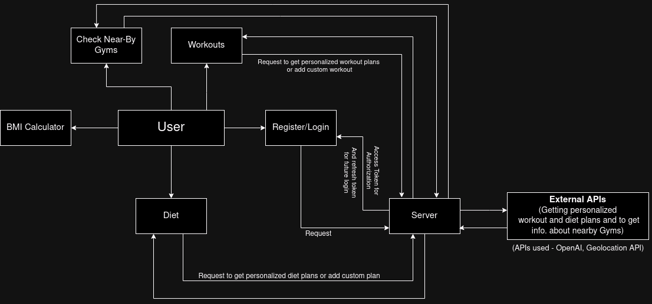

**7. Deployment**

NattyWorld can be deployed on cloud platforms like Heroku, AWS, or DigitalOcean. Frontend hosting services such as Netlify or Vercel, coupled with MongoDB Atlas for database hosting, offer a robust deployment solution.

**8. Testing**

Unit tests for frontend components using Jest and backend APIs using tools like Mocha/Chai ensure robustness. Additionally, integration tests with Cypress cover end-to-end scenarios.

**9. Scalability and Performance**

NattyWorld is designed for scalability, employing caching mechanisms, load balancing, and horizontal scaling strategies. Performance optimizations guarantee fast response times and efficient resource utilization.

**10. Security**

NattyWorld prioritizes security by encrypting sensitive data, implementing input validation, safeguarding against common web vulnerabilities, and utilizing secure authentication mechanisms like JWT tokens.

**11. Accessibility**

Adhering to web accessibility standards ensures usability for all users. Features such as alternative text for images, keyboard navigation support, and semantic HTML markup enhance accessibility.

**12. Maintenance and Support**

Regular maintenance, updates, and a robust support system address user inquiries, bug reports, and feature requests promptly, ensuring a seamless user experience.

**13. Conclusion**

NattyWorld endeavors to provide a comprehensive fitness platform, empowering users to achieve their fitness goals effectively. By embracing the outlined design principles and implementing suggested features, NattyWorld aims to foster a healthy lifestyle journey for its users.